**ICP-3**

**Github link**:

1. **Numpy:**
2. Using NumPy, create a random vector of size 15 having only integers in the range 1-20.

**Code:**

**Output:**

**Description:**

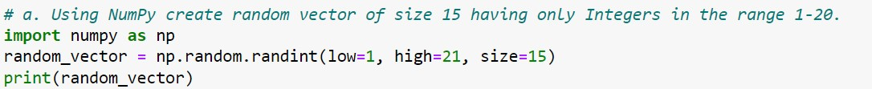

1. Import numpy
2. random.randint() function returns the random integer values of given size within the lower and higher limits provided
3. Reshape the array to 3 by 5

**Code:**

**Output:**

**Description:**

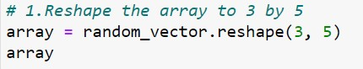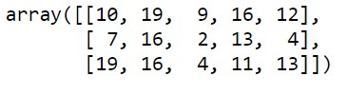

1. Print the array shape.

**Code:**

**Output:**

**Description:**



|  |  |
| --- | --- |
| 1. | shape function gives the information of the current shape(dimensions) of an array |

|  |  |
| --- | --- |
| 1. | reshape() function allows to reshape an array with required dimensions |

1. Replace the max in each row by 0

**Code:**

**Output:**

**Description:**

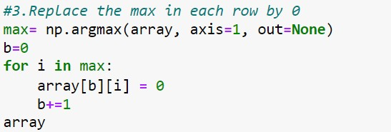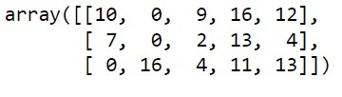

|  |  |
| --- | --- |
| 1. | argmax() is used to get an array of indices of max values of a given array of single dimensions or multi-dimensional. |
| 2. | axis=1 gives the index from rows |

Create a 2-dimensional array of size 4 x 3 (composed of 4-byte integer elements), and also print the shape, type and data type of the arrayenables you to display the percent value using Python string formatting

**Code:**

**Output:**

**Description:**

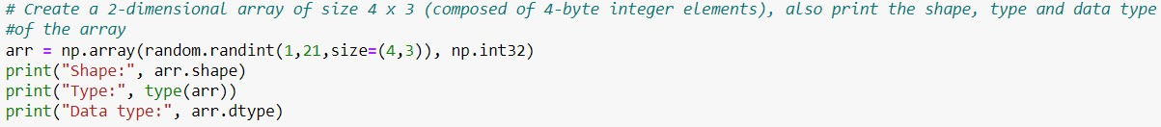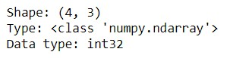

|  |  |
| --- | --- |
| 1. | shape function gives the information of the current shape(dimensions) of an array |
| 2. | type() used to get the type of an object |
| 3. | Data type used to define the type of a variable |

1. Write a program to compute the eigenvalues and right eigenvectors of a given square array given below: [[ 3 -2] [ 1 0]]

**Code:**

**Output:**

**Description:**

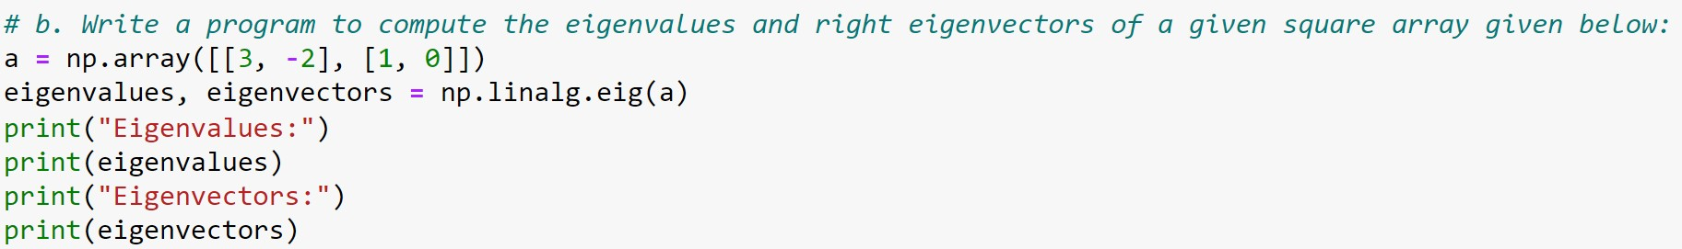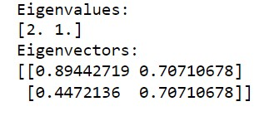

* + 1. linalg(linear algebra) includes several tools for working with linear algebra problems such as functions for performing matrix calculations, eigenvalues and eigen vectors
    2. eig() function computes the eigenvalues and right eigenvectors of a given square array.

1. Compute the sum of the diagonal elements of a given array.

**Code:**

**Output:**

**Description:**

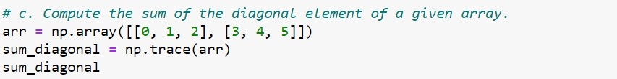

|  |  |
| --- | --- |
| 1. | trace() function to compute the sum of the diagonal elements of the array |

1. Write a NumPy program to create a new shape to an array without changing its data. Reshape 3x2: [[1 2]

[3 4]

[5

6]]

**Code:**

**Output:**

Reshape

2

x

3:

[[1

2

3]

[4

5

6]]

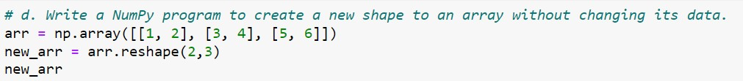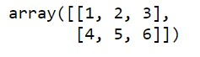

**Code:**

**Output:**

**Description:**

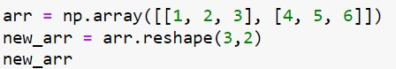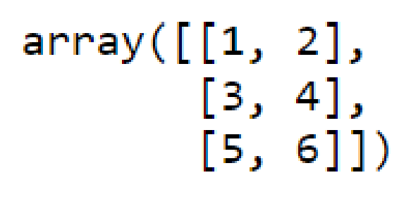

* 1. reshape() allows to change the dimensions of the given array without changing the data